Chord Ornamentation

For this lesson, take 3 or 4 first position or “cowboy” chords and place them in any order you like and play them at whatever tempo you wish. You may notice that after a while your chosen chord progression, without any additional melody, is getting a little stale.

One way to spice up your chord progressions (using simple cowboy chords) is to alternate open strings and your regular fretted note. For example, a C chord can have lots of variety just simply by removing one finger and replacing it.

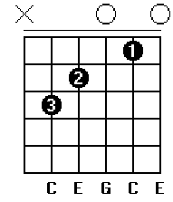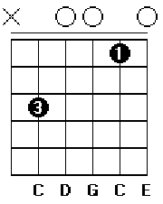

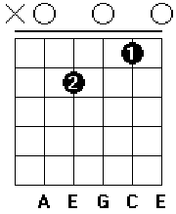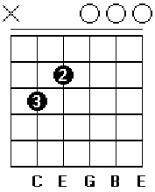

You can also get a very pleasing sound by integrating a melody into your chord movement. This idea is called “voice leading” and helps to add interest to chord progressions. It can be applied to any chord progression in any key.

In the next example there are two main chords: C and F. If you simply strum these chords one after the other, the progression gets stale VERY fast. However if you add a simple melody between the two chords adds interest and creates more movement in what would otherwise be very simple music. In this example, the melody is highlighted and the chords are left in black.

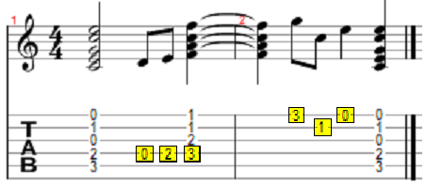

When done right, this will work for just about any set of chords. After a decent amount of practice, these types of ideas will come naturally to you and you will be able to make these up on the fly.

